Project Management Documents – Sprint 1
Team: Notavirus.exe
Project Manager: Phinehas Maina

Work Breakdown Structure (WBS)
  - Project Initiation
    - Team Roles – Team
  - User Stories & Requirements - Team
    - Write User stories and scenarios – Team
    - Have user stories/scenarios approved by Prof. Hobbs –
Primary: Lauryn
Secondary: Team
    - Prioritize features for Sprint 1 - Team

  - Faculty Management
    - Add New Faculty – Add a New Faculty
Primary: Luke
Secondary: Ashton
    - Modify Existing Faculty – Modify Existing Faculty
Primary: Lauryn
Secondary: Hailey
    - Delete Faculty
Primary: Hailey
Secondary: Keller
  - Course Management
    - Add New Course – Add a New Course
Primary: Brooks
Secondary: Luke
    - Modify Existing Course – Modify a Course
Primary: Hailey
Secondary: Lauryn
    - Delete Course – Delete a Course
Primary: Lauryn
Secondary: Brooks

  - Conflict Management
    - Add New Conflict – Add a New Conflict
Primary: Hailey
Secondary: Ashton
    - Modify Existing Conflict – Modify a Conflict
Primary: Luke
Secondary: Lauryn
    - Delete Conflict – Delete a Conflict
Primary: Lauryn
Secondary: Luke

  - Lab Management
    - Add New Lab – Add a New Lab
Primary: Ashton
Secondary: Hailey
    - Modify Existing Lab – Modify a Lab
Primary: Brooks
Secondary: Lauryn
    - Delete Lab – Delete a Lab
Primary: Luke
Secondary: Phin

  - Room Management
    - Add New Room – Add a New Room
Primary: Keller
Secondary: Brooks
    - Modify Existing Room – Modify a Room
Primary: Keller
Secondary: Luke
    - Delete Room – Delete a Room
Primary: Ashton
Secondary: Keller

  - Configuration & Display
    - Print Config File – Display the Scheduler
Primary: Brooks
Secondary: Hailey

  - Scheduler
    - Run Scheduler – Run the Scheduler
Primary: Keller
Secondary: Hailey
Third: Ashton
Fourth: Lauryn

Network Diagram

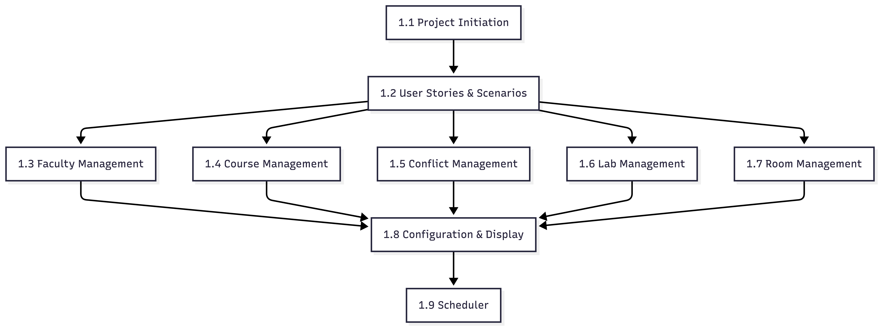

Schedule Table

